Name : Kirtesh Satish Admute
Roll No. : 258039
PRN : 250841220082
Module : DBT

use iacsd0925;

-- 1. Write a query to display the first day of the month (in datetime format) three months before the current month.
-- Sample current date : 2014-09-03
-- Expected result : 2014-06-01
SELECT date_sub(date_sub(curdate(), interval 3 month), interval day(curdate() - 1 ) day );

-- SELECT date_add(date_sub(date_sub(curdate(), interval 3 month), interval day(curdate()) day ), interval 1 day);
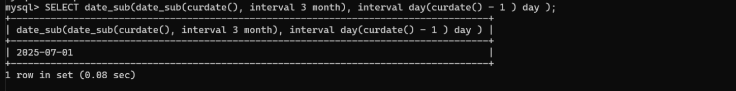

-- 2. Write a query to display the last day of the month (in datetime format) three months before the current month.
SELECT date_sub(date_sub(curdate(), interval 2 month), interval day(curdate() - 1 ) day );
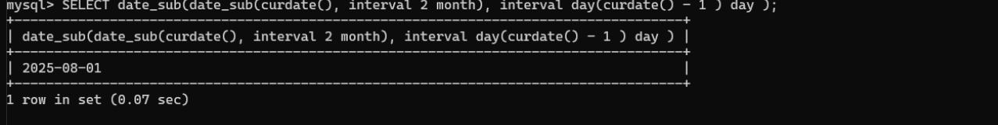

-- 3. Write a query to get the distinct Mondays from hiredate in emp tables.
SELECT empno ,ename , date_format(hiredate,'%W') as day_of_week from emp
where date_format(hiredate,'%W') ='Monday';
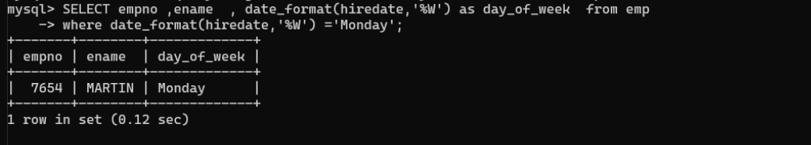

-- 4. Write a query to get the first day of the current year.
-- SELECT date_sub(curdate(), interval month(curdate()) month );
SELECT date_sub((date_sub(curdate(), interval month(curdate())-1 month )), interval day(curdate() )-1 day);
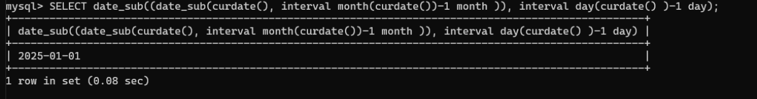

-- 5. Write a query to get the last day of the current year.
-- SELECT last_day(date(curdate()))
SELECT date_sub((date_sub(curdate(), interval month(curdate())-1 month )), interval day(curdate() )-1 day);
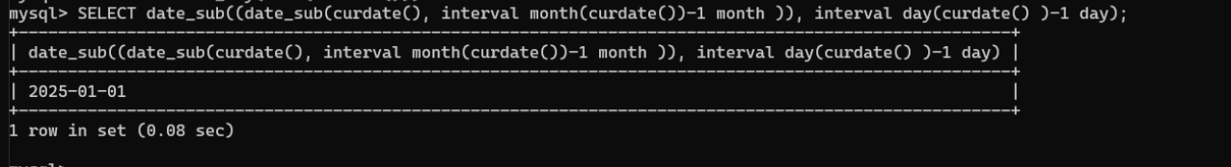

-- 6. Write a query to calculate your age in year.
SELECT timestampdiff(YEAR, '2001-08-30', curdate());
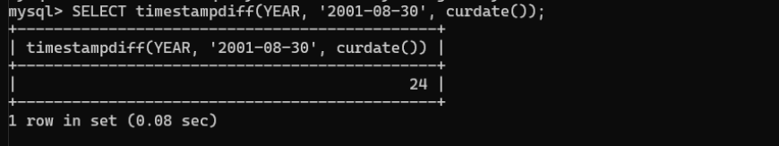

-- 7. Write a query to get the current date in the following format.
-- Sample date : 04-sep-2014
-- Output : September 4, 2014
SELECT date_format(date(curdate()), ' %M %d, %Y');
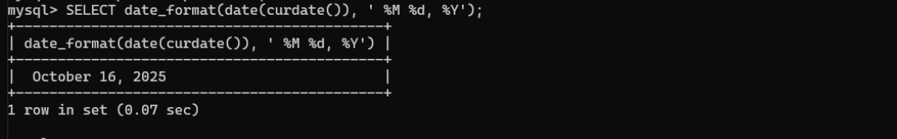

-- 8. Write a query to get the current date in Thursday September 2014 format.
-- Thursday September 2014
SELECT date_format(date(curdate()), '%W %M %Y');
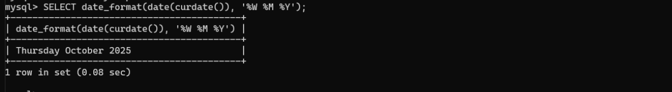

-- 9. Write a query to extract the year from the current date.
SELECT year(date(curdate()));
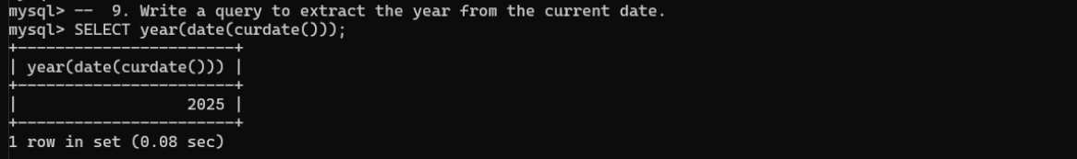

-- 10. Write a query to get the first name and hire date from the employees table where hire date between '1987-06-01' and '1987-07-30'
SELECT ename, hiredate from emp
WHERE hiredate between '1980-06-01'and '1987-07-30';
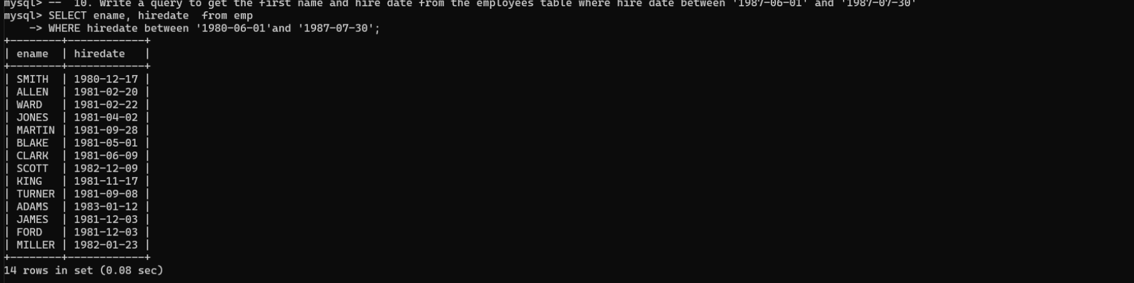

-- 11. Write a query to display the current date in the following format.
-- Sample output: Thursday 4th September 2014 00:00:00
SELECT date_format(curdate(), '%W %d %M %Y %T ') ;
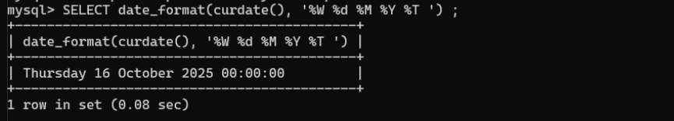

-- 12. Write a query to display the current date in the following format.
-- Sample output: 05/09/2014
SELECT date_format(curdate(), ' %d / %m / %y ') ;
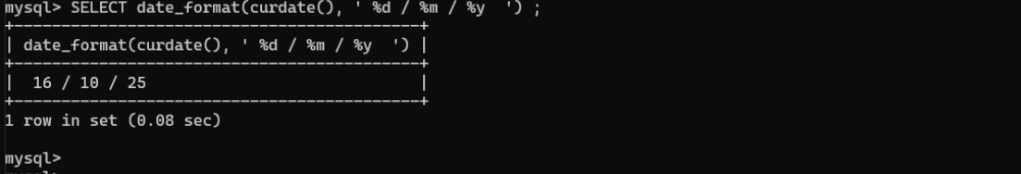

-- 13. Write a query to display the current date in the following format.
-- Sample output: 12:00 AM Sep 5, 2014
SELECT date_format(curdate(), ' %r %b %d , %Y ') ;
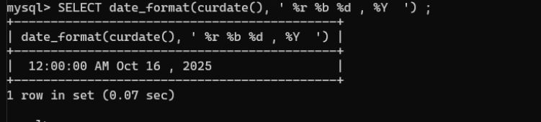
-- 14. Write a query to get the employees who joined in the month of June.
SELECT empno, ename ,date_format(hiredate,'%M') from emp
where date_format(hiredate,'%M') = 'June';
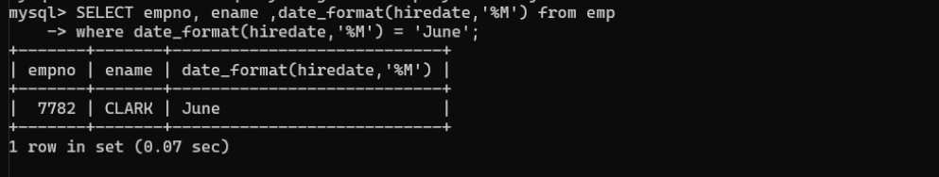

-- 15. Write a query to get the years in which more than 10 employees joined.
SELECT YEAR(hiredate) FROM emp
GROUP BY YEAR(hiredate)
HAVING COUNT(*) > 10;

-- 16. Write a query to get the first name of employees who joined in 1987.
SELECT ename
FROM emp
WHERE YEAR(hiredate) = 1987;
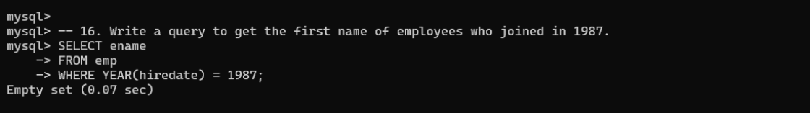

-- 17. Write a query to get employees whose experience is more than 5 years old.
SELECT *
FROM emp
WHERE datediff(curdate(),hiredate) > 365*5;
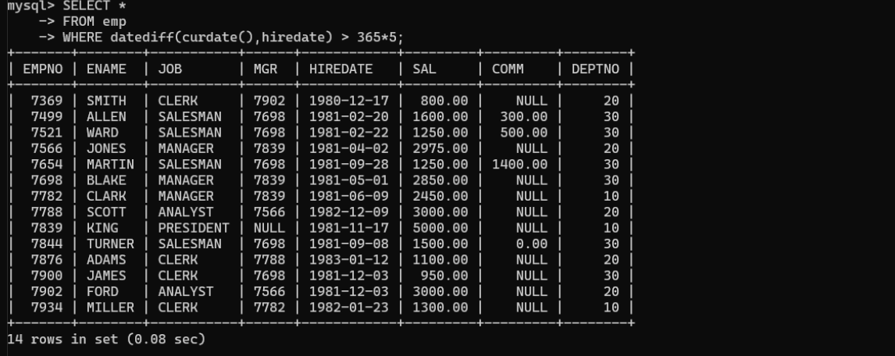

-- 18. Write a query to get employee ID, last name, and date of first salary of the employees.
SELECT empno, ename, min(hiredate) as 'First Salary Date'
FROM emp
GROUP BY empno, ename;

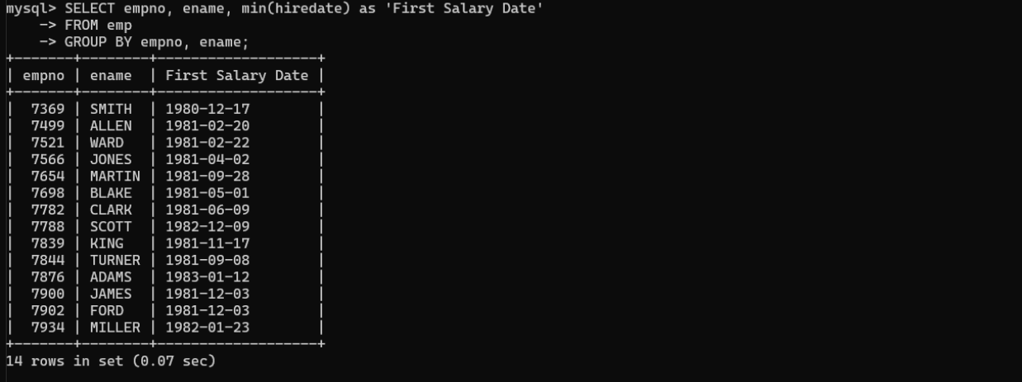

19.
SELECT ename, hiredate, CONCAT(FLOOR(DATEDIFF(CURDATE(), hiredate) / 365), ' years') as 'Experience'
FROM emp;
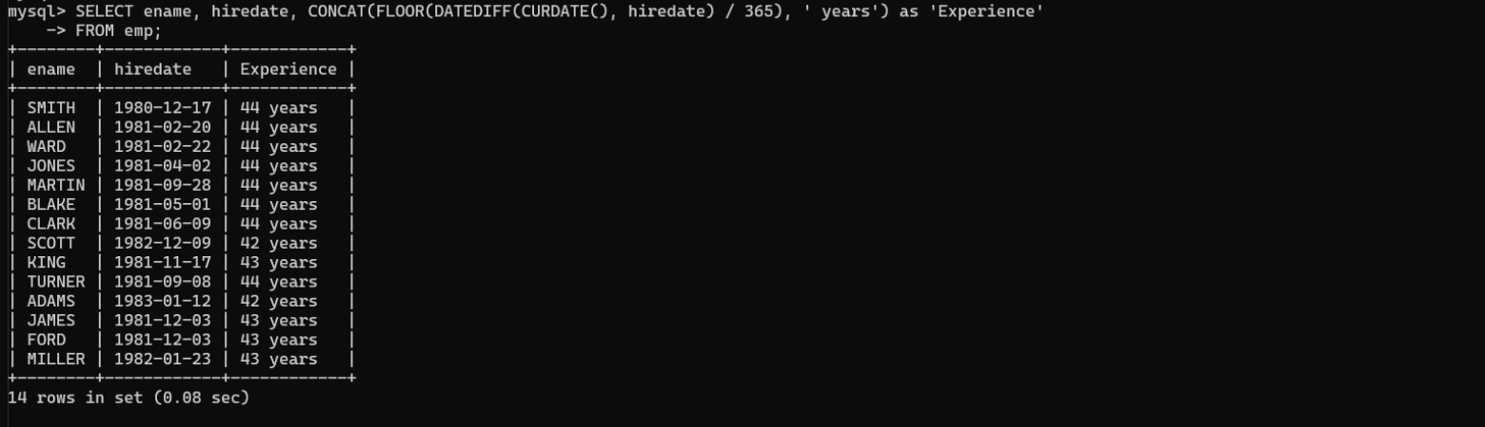

-- 20. Write a query to get the department ID, year, and number of employees joined.
SELECT deptno, YEAR(hiredate) as 'Year', COUNT(*) as 'No. of Employees Joined'
FROM emp
GROUP BY deptno, YEAR(hiredate);

